**Problem Statement**

**Product Dissection for top leading Platforms**

Welcome to this case study on dissecting and designing products for top leading platforms. In this case study, you will delve into the intriguing world of schema design for a prominent platform of your choice. Your task is to choose a top leading platform, research its features, and meticulously craft a schema design that encapsulates the essence of its functionality. By focusing on key entities, attributes, and relationships, you will gain invaluable insights into how data architecture drives the platform's effectiveness.

**Step 1: Choose a Leading Platform**

Select a leading platform of your choice, which could span various domains such as social media, e-commerce, finance, or any other industry. This choice will form the foundation of your exploration into its schema design.

**Step 2: Research:**

Thoroughly research the platform you have selected. Investigate its core features, functionalities, and user interactions. Identify the top features that define its user experience and contribute significantly to its popularity.

**Step 3: Product Dissection and Real-World Problems solved by the platform**

In this step, you will meticulously analyse the platform's standout features and how they provide innovative solutions to real-world challenges. By identifying key functionalities that resonate with users, you'll unravel how the platform effectively addresses problems and enhances user experiences. This dissection will serve as the foundation for understanding how the schema design aligns with the platform's core objectives.

**Step 4: Case Study on the real-world problems and approach to solving them**

In this pivotal step, you will expand on the real-world challenges uncovered in Step 3 through a comprehensive case study. Delve into specific instances where users encountered difficulties and showcase how the platform's unique features provided effective solutions. By dissecting the approach taken by the platform to overcome these challenges, you'll gain a deeper appreciation for the platform's user-centric design philosophy and how it shapes the schema design.

**Step 5: Schema Design Based on Top Features**

Based on the features you have identified, craft a schema design that reflects the platform's data structure. Focus on the key entities, attributes, and relationships that underpin the chosen features. Your schema should capture the essence of how the platform organises and utilises its data.

**Step 6: Rationale Behind the Design**

While creating the schema design, consider the rationale behind the platform's choices. Reflect on why certain entities and relationships were chosen and how they align with the platform's goals. This will help you understand the strategic decisions driving the schema's architecture.

**Step 7: Create an ER Diagram**

Utilise tools like the Miro platform or similar applications to create an illustrative Entity-Relationship (ER) diagram. This diagram should vividly depict the entities, attributes, and relationships present within your schema design. The ER diagram will serve as a visual representation of your insights.

**Step 8: Presentation of Findings**

Present your findings in a clear and concise manner. Showcase your understanding of how the schema design impacts the platform's functionality and user experience. Explain how your chosen features are integrated into the schema and how the schema's structure supports the platform's objectives.

**Task Details:**

1. **Answer Submission:** Your submission should include well-structured solutions for all provided questions related to product schema designs.
2. **Video Creation:** Create an informative and engaging video where you thoroughly explain the Case Study.
3. **Depth and Clarity:** Ensure your solutions are detailed and showcase your understanding of product schema design principles. Similarly, in the video, provide clear explanations that are easy to understand for a wide audience.
4. **Creativity Encouraged:** You are welcome to utilise visuals, diagrams, or creative elements to enhance the clarity and impact of your explanations.

**Note:**

1. Duplicate this document and proceed to write your solutions and prepare your video.
2. Include the video link in this document before final submission.

Best of luck in completing this project and showcasing your prowess in dissecting and designing product schema for leading platforms! **For reference, we have also conducted a case study on Zomato, which you can find below. This case study will provide you with valuable insights into how schema design plays a pivotal role in shaping the functionality and success of a prominent platform.**



**Product Dissection for Zomato**

### **Company Overview:**

### Zomato, founded in 2008 by **Deepinder Goyal** and **Pankaj Chaddah**, is a leading global platform for restaurant discovery, food delivery, and dining out. Initially launched as *Foodie Bay*, it rebranded to Zomato in 2010, reflecting its growth and ambition to cater to a global audience.

### **Product Dissection and Real-World Problems Solved by Zomato:**

### Zomato, a global leader in food delivery and restaurant discovery, has effectively addressed real-world challenges through its innovative product offerings. With a focus on connecting customers with dining experiences, Zomato empowers users to discover, explore, and enjoy food in a seamless manner. By offering features like detailed restaurant profiles, verified reviews, and real-time order tracking, Zomato provides a solution to the challenges of finding reliable dining options and efficient food delivery services. These core features bridge the gap between diners, restaurants, and delivery partners, enabling a streamlined experience for all parties involved.

### Zomato's groundbreaking functionalities, such as personalized restaurant recommendations, robust filtering options, and live delivery updates, have revolutionized how users interact with food services. By addressing the challenge of restaurant overload in urban areas, Zomato curates tailored options that help users discover the best dining experiences. Additionally, the integration of authentic, verified reviews fosters trust among users, ensuring informed decision-making. Features like Zomato Gold and Pro subscriptions further enhance user loyalty by offering exclusive benefits, while digital menus with dish categorization simplify the ordering process.

### In conclusion, Zomato's product design has successfully tackled real-world challenges by creating a platform that enhances food discovery, ensures reliable delivery, and fosters loyalty among users. Through its diverse features, Zomato addresses the need for efficient dining solutions, authentic reviews, and sustainable delivery practices, shaping the food-tech landscape and providing practical solutions to the evolving needs of its global user base.

### **Case Study: Real-World Problems and Zomato's Innovative Solutions**

Zomato, a leading food delivery and restaurant discovery platform, has not only revolutionized the way we dine and order food but has also addressed significant real-world challenges through its innovative features. By identifying user needs and leveraging technology, Zomato has positioned itself as a solution-driven platform that connects customers with restaurants, enhances delivery efficiency, and improves dining experiences.

#### **Problem 1: Difficulty in Restaurant Discovery**

**Real-World Challenge:** With a multitude of dining options in urban areas, users often struggle to find restaurants that match their preferences and budget.

**Zomato's Solution:**

Zomato provides a comprehensive search and filtering system that allows users to explore restaurants by location, cuisine, price, and dietary needs. Personalized recommendations, based on user behaviour and reviews, further streamline the discovery process. Detailed restaurant profiles, complete with menus, photos, and ratings, ensure that users can make informed decisions.

#### **Problem 2: Unreliable Reviews and Ratings**

**Real-World Challenge:** Fake or biased reviews often mislead users, making it challenging to trust the feedback on dining platforms.

**Zomato's Solution:**

Zomato mitigates this issue by verifying reviews and linking them to completed orders or visits. It encourages users to provide honest, detailed feedback that others can rely on. Trends and aggregated ratings further enhance transparency and trustworthiness.

#### **Problem 3: Inefficient Food Delivery**

**Real-World Challenge:** Food delivery delays and lack of transparency in order tracking often frustrate customers.

**Zomato's Solution:**

Zomato optimizes delivery operations through real-time order tracking and efficient partner assignments based on traffic and location data. This approach not only improves delivery speed but also provides customers with transparency and confidence in the service.

#### **Problem 4: Overwhelming Menu Choices**

#### **Real-World Challenge:** Browsing through extensive menus can overwhelm users, leading to indecision and delays in ordering.

**Zomato's Solution:**

Zomato categorizes menu items with filters such as popularity, dietary preferences, and pricing. Visuals of dishes and recommended combinations make the ordering process easier and more appealing for users.

#### **Problem 5: Enhancing Customer Loyalty**

#### **Real-World Challenge:** Frequent users often look for added benefits or rewards to stay engaged with a platform.

**Zomato's Solution:**

Zomato introduced loyalty programs like **Zomato Gold** and **Zomato Pro**, offering exclusive discounts, free deliveries, and priority support. These features not only reward regular users but also foster long-term customer loyalty.

#### **Conclusion:**

### Zomato's innovative solutions to these real-world problems have established it as a leader in the food-tech space. By addressing challenges like restaurant discovery, review authenticity, delivery inefficiencies, and sustainability, Zomato continues to enhance its services and improve user experiences.

### **Top Features of Zomato:**

1. **User Profiles:** Zomato allows users to create personal profiles, featuring usernames, full names, profile pictures, and order histories. This personalized online presence reflects each user's preferences and dining habits, enabling them to interact meaningfully with the platform.
2. **Restaurant Listings:** Zomato provides detailed restaurant profiles with essential information, including menus, photos, contact details, operating hours, and average costs. These listings are enriched with user reviews and ratings, helping diners make informed decisions.
3. **Search and Filters:** The platform offers robust search capabilities with filters for location, cuisine, price range, and dietary preferences. Advanced search algorithms recommend restaurants tailored to user tastes and past behaviours.
4. **Order Placement and Tracking:** Zomato enables seamless food ordering from partner restaurants. Users can track their orders in real time, providing transparency and a better experience with delivery estimates and status updates.
5. **Reviews and Ratings:** Zomato encourages users to share feedback by writing reviews and providing ratings for restaurants. Verified reviews ensure authenticity, fostering trust among the user base.
6. **Loyalty Programs:** Features like **Zomato Gold** and **Zomato Pro** offer user’s exclusive benefits, such as discounts, free deliveries, and priority service. These programs enhance user retention and engagement.
7. **Social** **Engagement:** Users can like and share reviews, rate dishes, and comment on posts. This social element fosters interaction and builds a community of food enthusiasts.
8. **Delivery** **Partner** **Optimization:** Zomato assigns delivery partners intelligently based on factors like location and traffic. This ensures faster delivery times and a smoother experience for customers.

### **Schema Description:**

The schema for Zomato involves multiple entities that represent different aspects of the platform. These entities include **Users, Restaurants, Menus, Orders, Reviews, Delivery Partners**, and more. Each entity has specific attributes that describe its properties and relationships with other entities.

**User Entity:**

Users are at the core of Zomato. The user entity contains information about each user:

* **UserID (Primary Key):** A unique identifier for each user.
* **Username**: The chosen username for the user's account.
* **Email**: The user's email address for account-related communication.
* **Full_Name**: The user's full name as displayed on their profile.
* **Phone:** The user's contact number for verification and communication.
* **Registration_Date**: The date when the user joined Zomato.

**Restaurant Entity:**

Restaurants represent dining establishments listed on Zomato:

* **RestaurantID (Primary Key):** A unique identifier for each restaurant.
* **Name:** The name of the restaurant.
* **Location:** The physical address of the restaurant.
* **Cuisine:** The type(s) of cuisine served.
* **Rating:** The average rating based on user reviews.
* **Contact_Info:** Phone number and email address for communication.

**Order Entity:**

Orders track food purchases made by users:

* **OrderID (Primary Key):** A unique identifier for each order.
* **UserID (Foreign Key referencing User Entity):** The user placing the order.
* **RestaurantID (Foreign Key referencing Restaurant Entity):** The restaurant fulfilling the order.
* **OrderStatus:** The status of the order (e.g., pending, completed).
* **OrderDate:** The date and time the order was placed.
* **TotalPrice:** The total cost of the order.

**Review Entity:**

Reviews capture user feedback about restaurants:

* **ReviewID (Primary Key):** A unique identifier for each review.
* **UserID (Foreign Key referencing User Entity):** The user writing the review.
* **RestaurantID (Foreign Key referencing Restaurant Entity):** The restaurant being reviewed.
* **Rating:** The numerical rating provided by the user.
* **Comment:** The text feedback from the user.
* **ReviewDate:** The date when the review was posted.

**Delivery Partner Entity:**

Delivery partners handle the logistics of food delivery:

* **PartnerID (Primary Key):** A unique identifier for each delivery partner.
* **Name:** The name of the delivery partner.
* **Contact_Info:** Contact information for communication.
* **AssignedOrderID (Foreign Key referencing Order Entity):** The order assigned to the delivery partner.

**Delivery Route Entity:**

Delivery routes track the journey of an order:

* **RouteID (Primary Key):** A unique identifier for each delivery route.
* **PartnerID (Foreign Key referencing Delivery Partner Entity):** The delivery partner assigned to the route.
* **EstimatedTime:** The estimated delivery time.
* **CurrentLocation:** The real-time location of the delivery partner.

**Relationships are:**

* **Users place Orders –** Each user can place multiple orders, and each order belongs to a single user.
* **Restaurants provide Menus –** Each restaurant has a menu, and a menu belongs to a single restaurant.
* **Orders are linked to Restaurants –** Each order is associated with one restaurant.
* **Users write Reviews –** Each user can write multiple reviews, and each review is linked to a single restaurant.
* **Delivery Partners handle Orders –** Each delivery partner may handle multiple orders, but each order is assigned to one delivery partner.

**ER Diagram:**

The ER diagram for Zomato illustrates the relationships and attributes of its key entities, including Users, Restaurants, Menus, Orders, Reviews, Delivery Partners, and Delivery Routes. Each entity is connected to others through well-defined relationships that showcase the platform's data flow. Users interact with Restaurants by placing Orders, writing Reviews, and exploring Menus, while Delivery Partners manage the logistics of fulfilling these orders. The diagram highlights the attributes of each entity, such as user details, restaurant information, and order specifics, providing a comprehensive view of Zomato’s operational structure. By visualizing these connections, the ER diagram captures the intricate dynamics that ensure a seamless user experience.

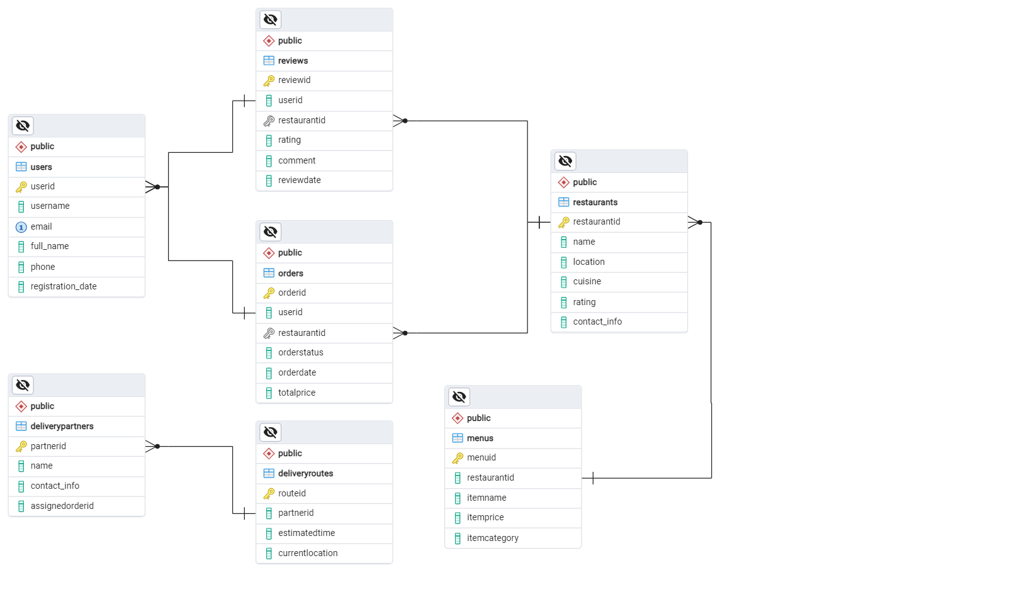

### **Conclusion:**

In this case study, we explored the design of Zomato's schema and Entity-Relationship diagram. Zomato has revolutionized the way people discover restaurants, order food, and share dining experiences, fostering seamless connections between users, restaurants, and delivery partners. The platform's intricate data model, consisting of entities like users, restaurants, menus, orders, reviews, and delivery partners, forms the foundation for its smooth functionality. By understanding this schema, we gain valuable insight into how Zomato efficiently manages complex operations and user interactions, contributing to its widespread success and continued growth as a leader in the global food-tech industry.

